**ARC Curator User’s Guide**

Last Updated: March 13, 2020

Table of Contents

**Overview**1

History of the Dashboard1

Your Role as a Curator1

Your Role as an Admin1

**Getting Started**2

Logging into the Dashboard2

Dashboard Tour3

**The Process**4

Ingesting a Record6

Finding/Selecting a Record7

Associating a Granule with a Collection7

Reviewing a Collection9

Reviewing a Granule15

Marking a Record ‘Done’19

Obtaining Metrics20

**FAQs**22

**Overview:**

The purpose of this guide is to provide guidance on the entire process of metadata curation using the Common Metadata Repository (CMR) Metadata Curation Dashboard (hereinafter referred to as “the dashboard”).

History of the Dashboard

The dashboard, created by the ESDIS Metadata Tools Team, has been operational since June 2018. It is a web interface used extensively by the Analysis and Review of CMR (ARC) team and other science data users to curate metadata associated with Earth science datasets. Once inside the dashboard, curators are able to conduct a field by field analysis to identify issues within the metadata and assign a color code to communicate the urgency of their findings, all in an effort to improve the quality of the metadata, as well as its associated dataset’s usefulness and discoverability. Those findings are then shared with Distributed Active Archive Center (DAAC) personnel who can use the dashboard to view any recommendations that are made, request additional feedback, and make the necessary changes to improve their metadata quality. Detailed reports within the dashboard are also used to track DAACs’ progress towards improving their metadata and to generate improvement metrics.

Your Role as a Curator

As a curator, your primary responsibilities include:

* Ingesting new metadata records when necessary
* Reviewing both collections and their associated granules
* Making recommendations based on your review
* Ensuring your recommendations are consistent with guidelines agreed upon by your working group.

Your Role as an Admin

As an admin, in addition to the responsibilities listed above, you also have the capability to:

* Delete duplicate records
* Release detailed reports to DAACs once all reviews have been completed
* Generate improvement metrics and export them for further analysis

**Getting Started:**

As of December 2018, curators are required to have an Earthdata account in order to access the dashboard. To create a new account, please visit: <https://urs.earthdata.nasa.gov/users/new>. Once your account is created, please follow the steps in the next section to login to the dashboard.

Logging into the Dashboard

Access the dashboard at: [https://cmr-dashboard.earthdata.nasa.gov](https://cmr-dashboard.earthdata.nasa.gov/)

Login using your Earthdata login credentials. If you are unable to login, please notify the ARC team via email in order to gain access.

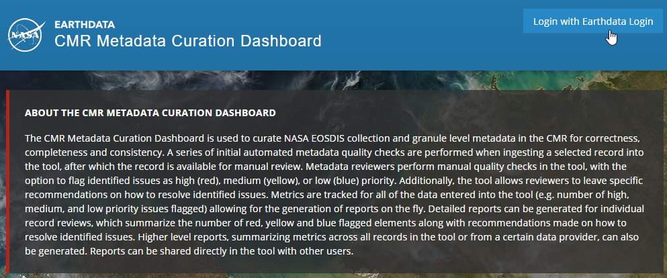

Once logged in, you will be directed to the homepage:

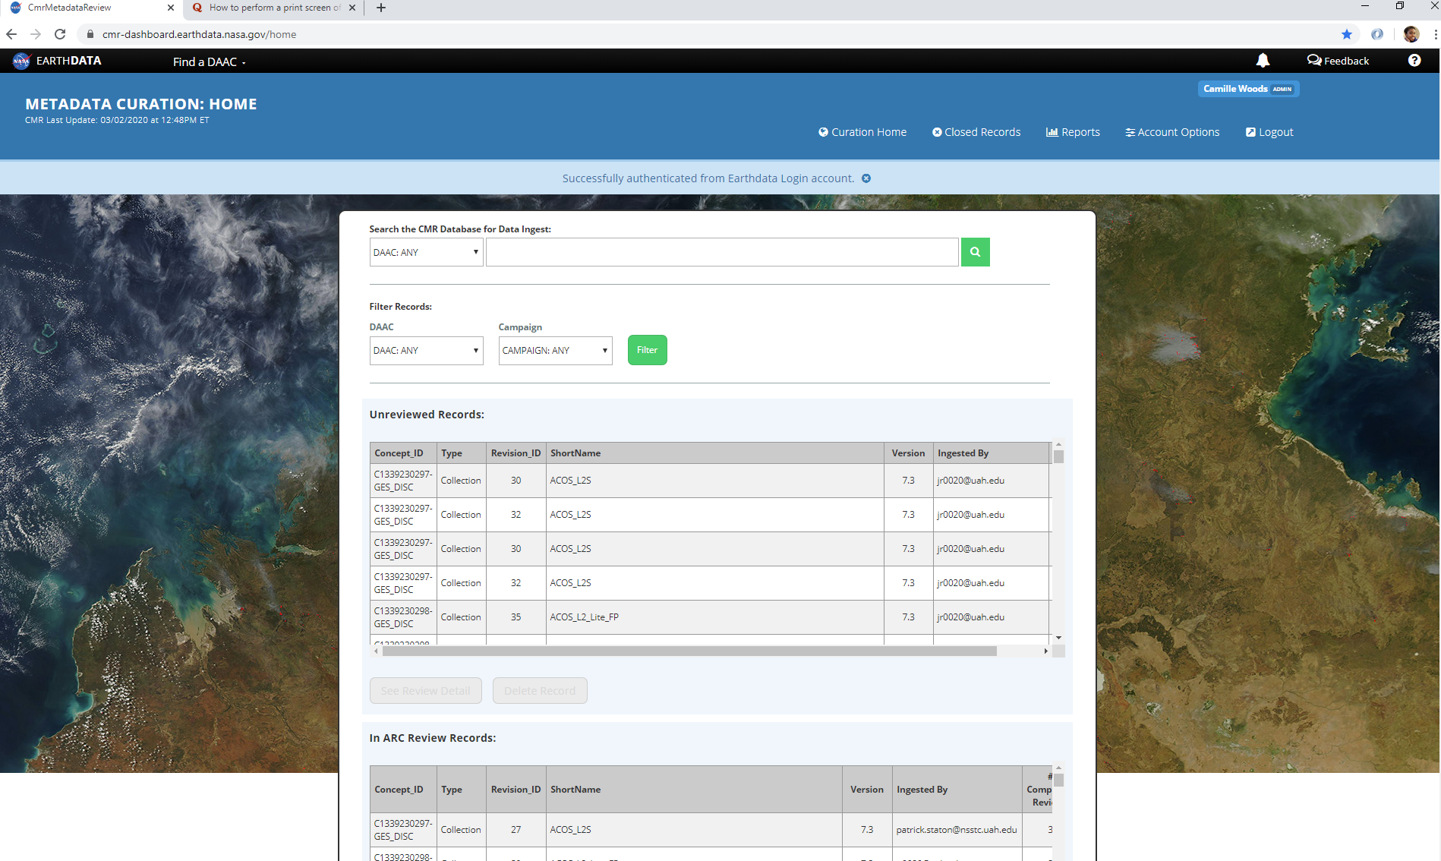

From there, you will be able to navigate to various areas of the dashboard. Each area’s functionality will be shown in the next section.

Dashboard Tour

After logging in, your username and your curation role will be listed in the top right corner of the homepage (shown in the white circle). You will then have the ability to navigate between the panes listed at the top of the homepage.



Click here to return to the homepage

Click here to bring in the newest revisions of records found in CMR (admins only)

Click here to view records that have been closed out

Click here to view curation progress

Another way for non-admin users to ingest new records is by placing the record’s short name or concept id into the search bar below.

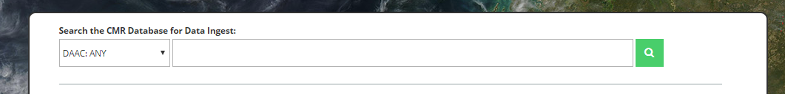

You will also notice on the homepage the option to “Filter Records by Campaign”:

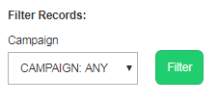

Records that have been ingested but not reviewed, can be located by looking in the section labeled “Unreviewed Records”.   
**Note**: This is usually where first reviewers find records they need to review.

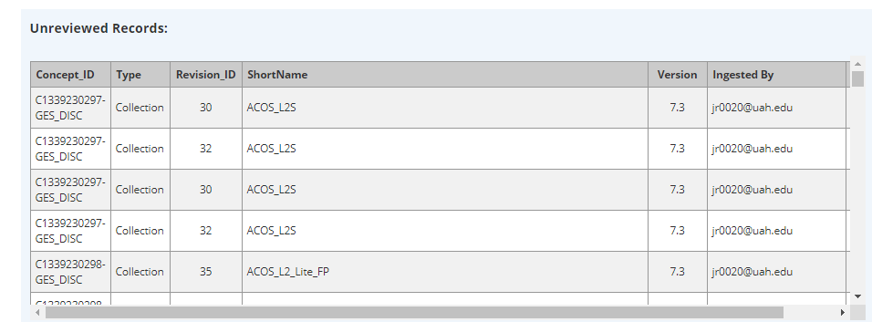

After a record undergoes an initial review, it can be found in the section labeled “In ARC Review Records”.   
**Note**: This is normally where second reviewers find records they need to review.

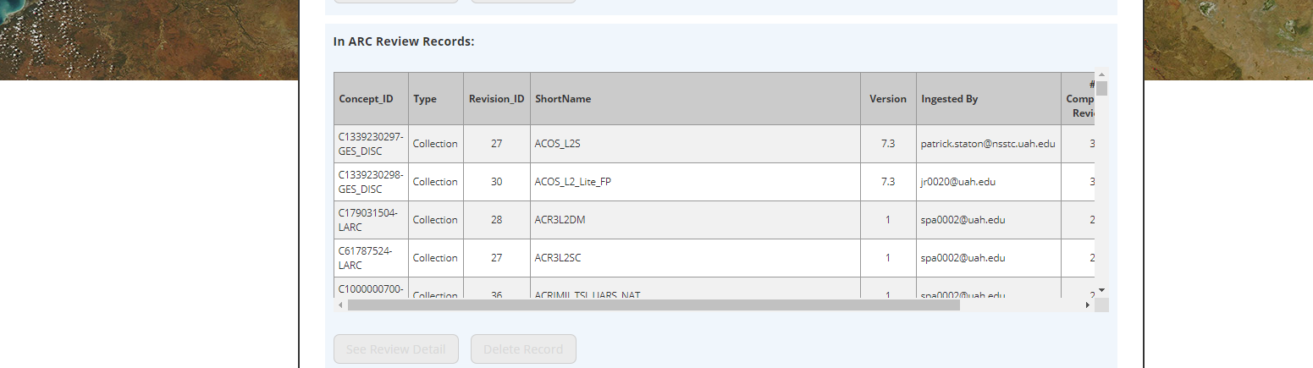

Once a record has had at least two reviews and is marked as “Done” in the dashboard, it will move down to the section labeled “Awaiting Release to DAAC”.   
**Note**: This is usually where Admins will find records they need to check prior to releasing them to a DAAC.

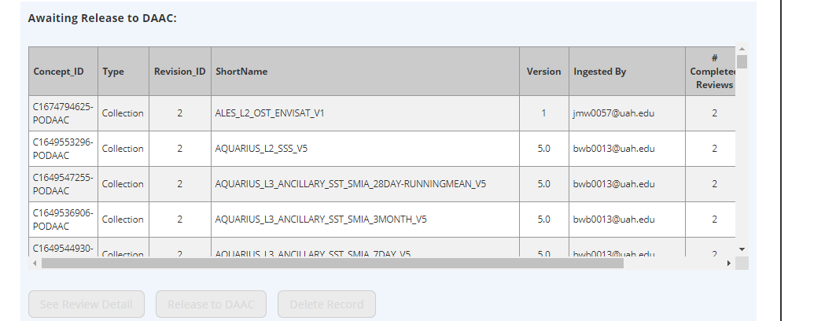

The very last section on the homepage is “Requires Curator Feedback Records”, which houses records that have been flagged by DAACs requesting feedback from reviewers.

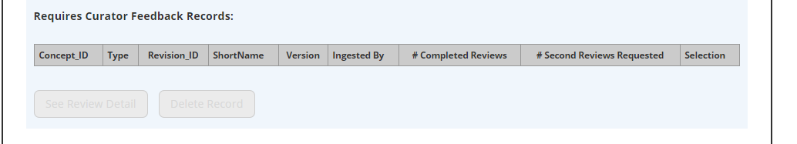

The next part of this guide will provide instructions on how to conduct a field by field analysis of a record using the dashboard.

**The Process:**

If you are the first reviewer, begin your review by searching for the record you need. This can be done by using the Ctrl+f shortcut and placing the record’s short name or concept id into the search bar that pops up. If no results are found, the record needs to be ingested.

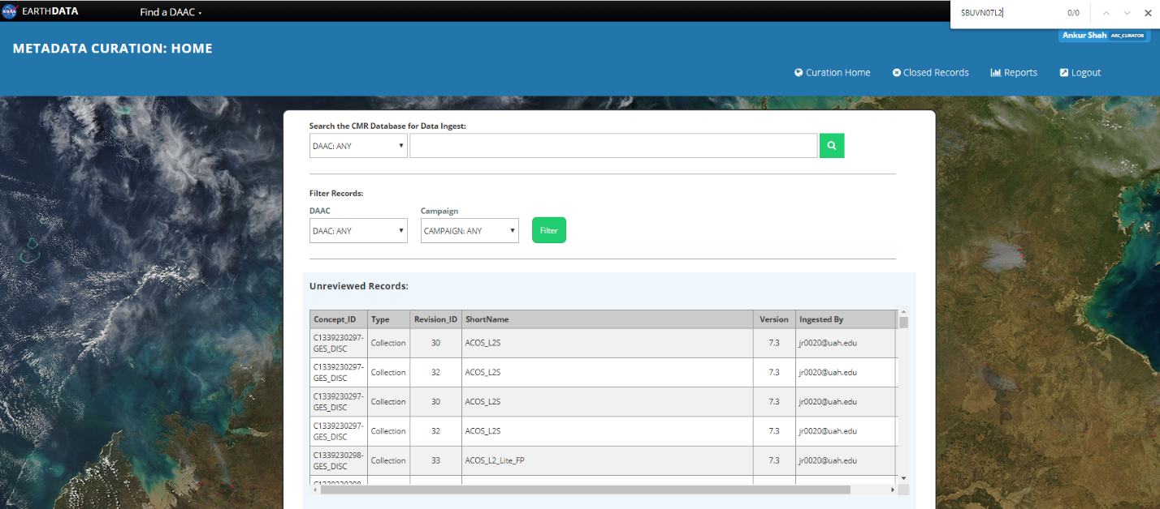

Ingesting a Record

To ingest a record, place the record’s short name or concept id into the search bar below and hit the green search button.

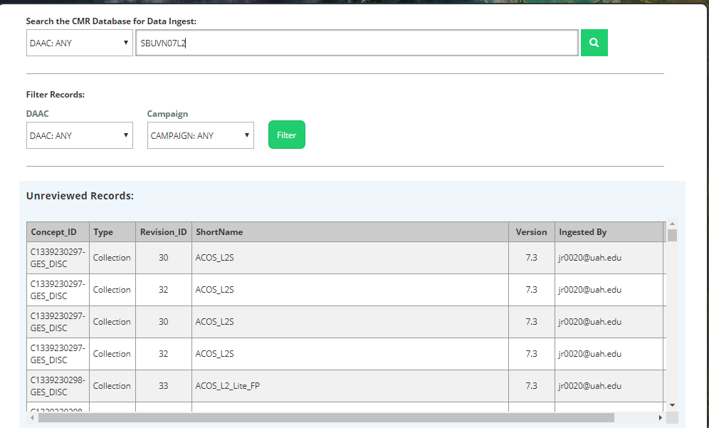

Select the circle underneath “Selection” and then hit “Select Collection”.

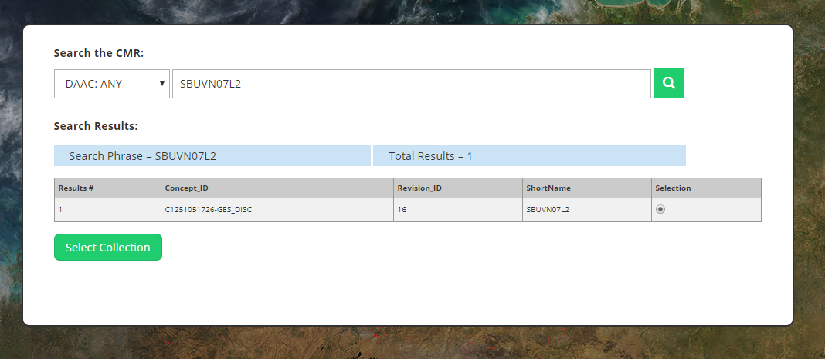

Select “Ingest Collection with Granules” to finish ingesting the record.

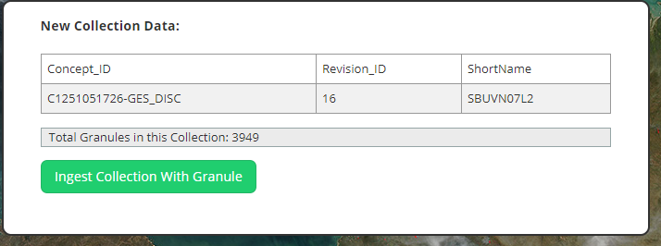

The following message should pop up at the top of the screen if ingestion is successful.

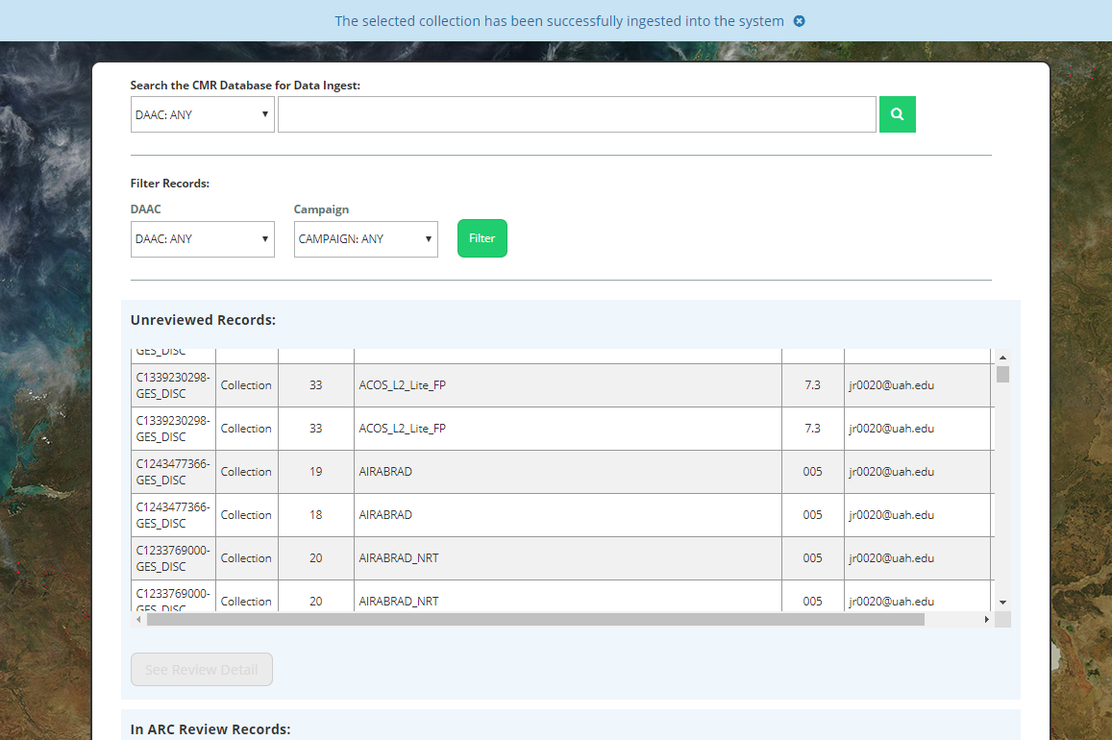

Finding/Selecting a Record

Once a record has been ingested, you can find it by using the Ctrl+f shortcut and locating it in the “Unreviewed Records” section (it should be highlighted). To select the record, hit the checkbox at the end of the row and select “See Review Detail”.

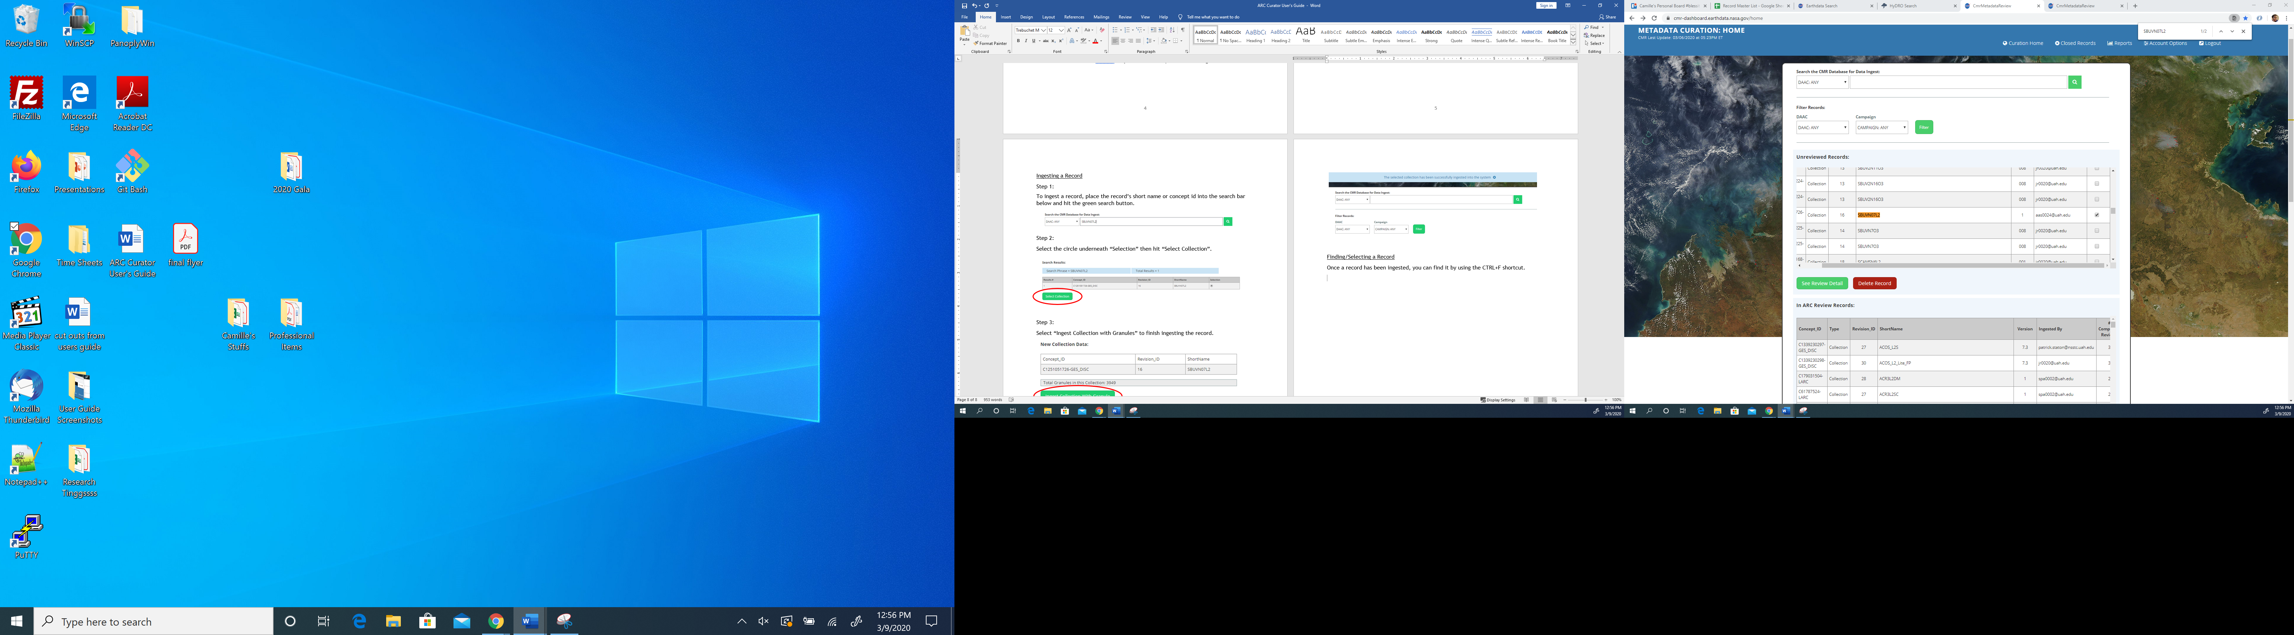

Once you click on “See Review Detail” it will take you to an overview page:

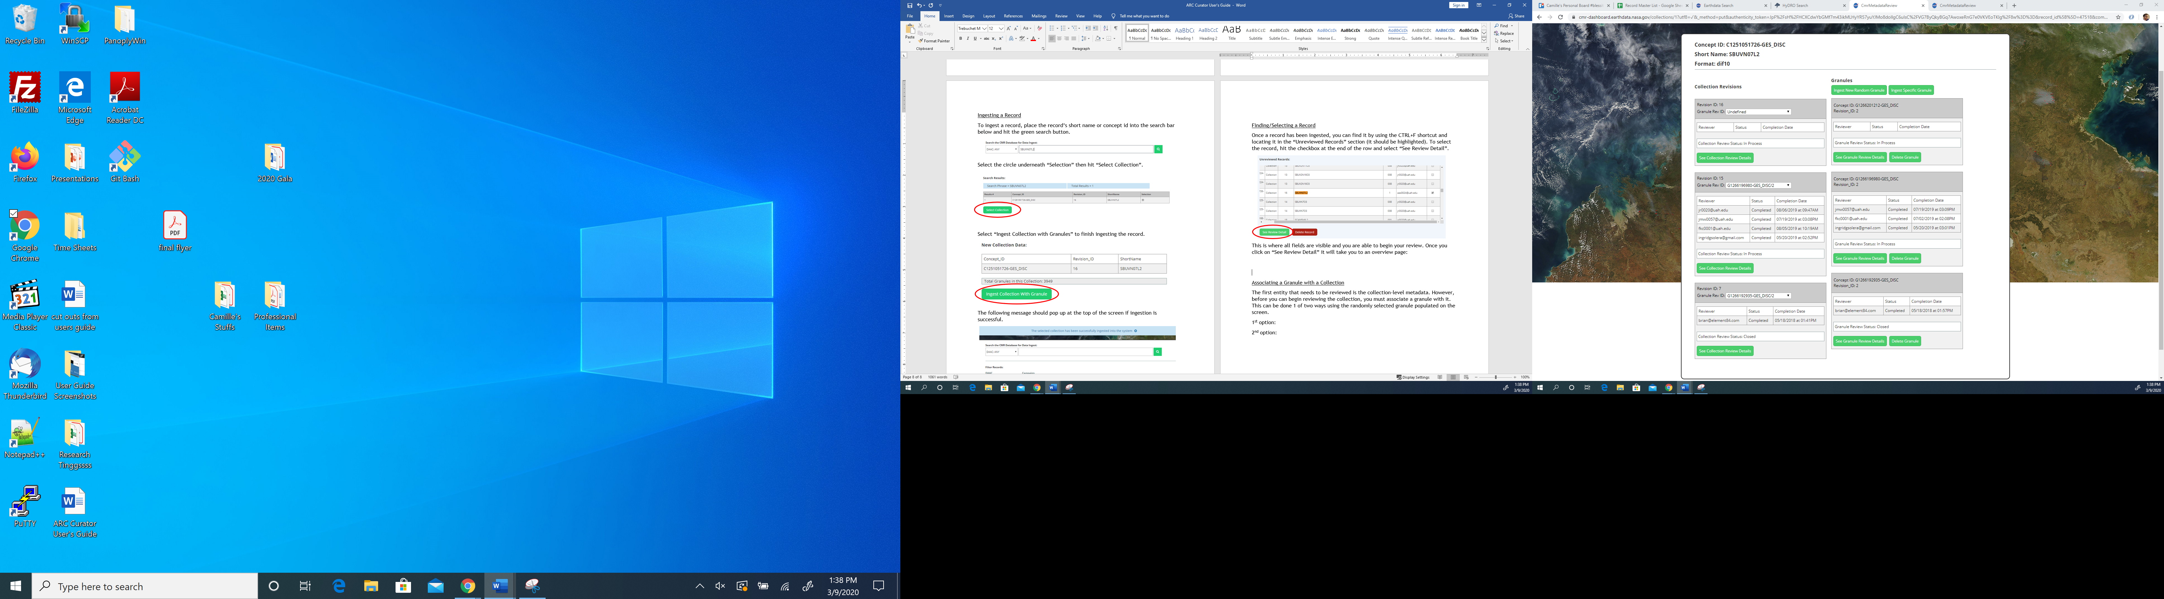

From this page, the collection level metadata elements can be accessed on the left, and the granule level metadata elements can be accessed on the right.

Associating a Granule with a Collection

To begin your review, you’ll need to associate the randomly selected granule on the right with the collection on the left. This can be done in one of two ways:

First Option (Drop Down Box):

Click the drop-down box that has “Undefined” listed on the left and select the Concept ID that matches the one listed on the right.

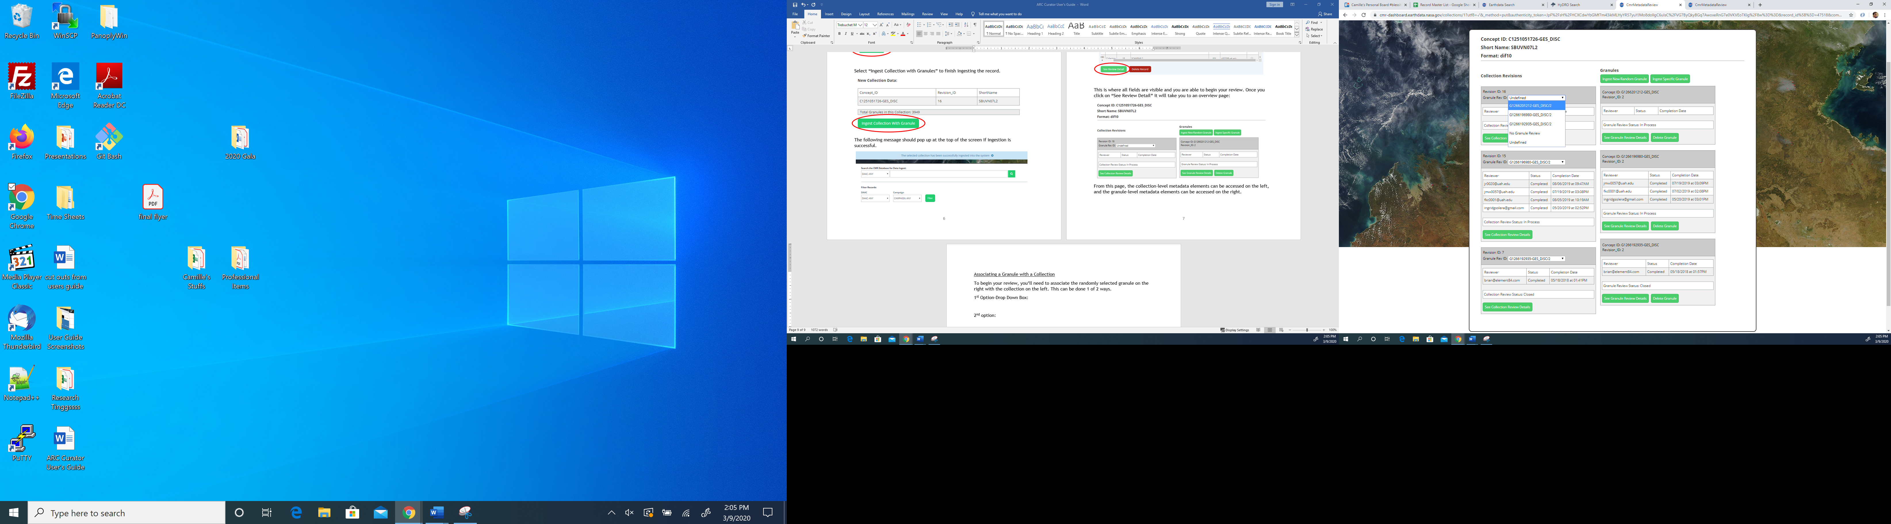

Second Option (Drag and Drop):

Click and drag “Revision_ID” over to the box that says “Undefined”. Once the box turns yellow, release your mouse to complete the association.

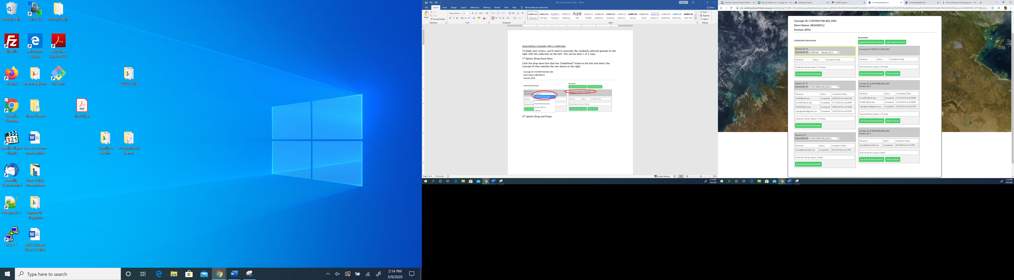

**Note:** If there are no granules available to associate with your collection, use the first option to select “No Granule Review”.

Now that you’ve successfully associated your collection and granule, it is time to begin reviewing each metadata element, beginning with the collection level elements first.

Reviewing a Collection

To begin reviewing the collection, select “See Collection Review Details”.

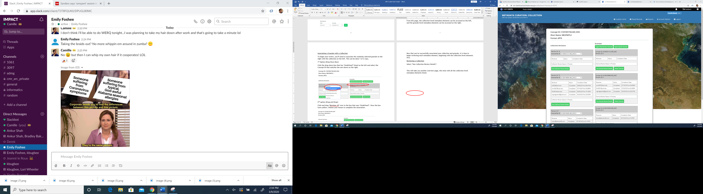

This will take you to a metadata elements overview page where you will begin your analysis. Each bubble on the page represents a metadata element in the collection level metadata record. At the end of your review, as noted by the legend at the bottom, elements with no issues will have green bubbles. Blue, yellow or red bubbles indicate that there is a recommendation with red being highest priority, and grey means that the metadata element is not applicable to the review. Bubbles with the number 2 inside of them indicate a reviewer requests a second opinion on the information provided for that element. Lastly, if a reviewer accidentally skips an element, its bubble will remain white until it is reviewed.

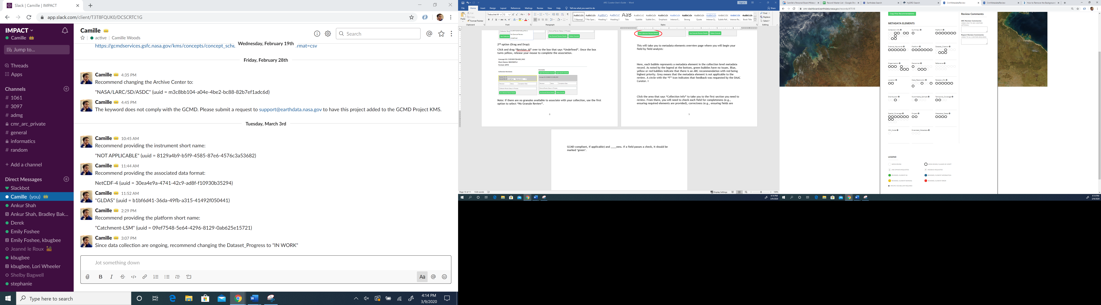

To begin reviewing each element, click the area that says “Collection Info”. From there, you will need to check each field for completeness (e.g., ensuring required elements are provided), correctness, and consistency (e.g., ensuring fields are GCMD-compliant, if applicable).

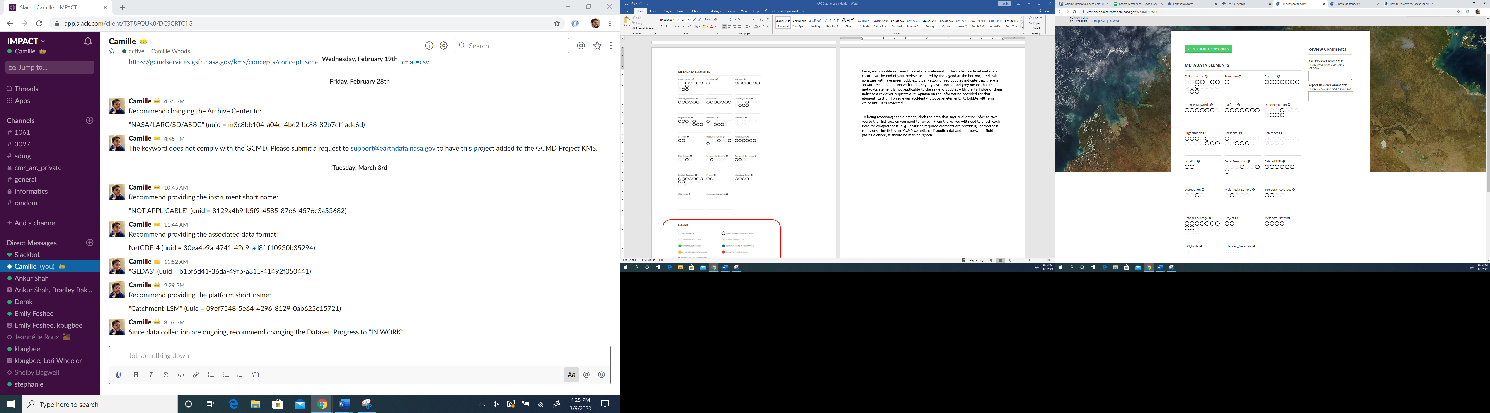

If a field passes a check, it should be marked ‘green’ by clicking the green arrow in the “Color Code” section.

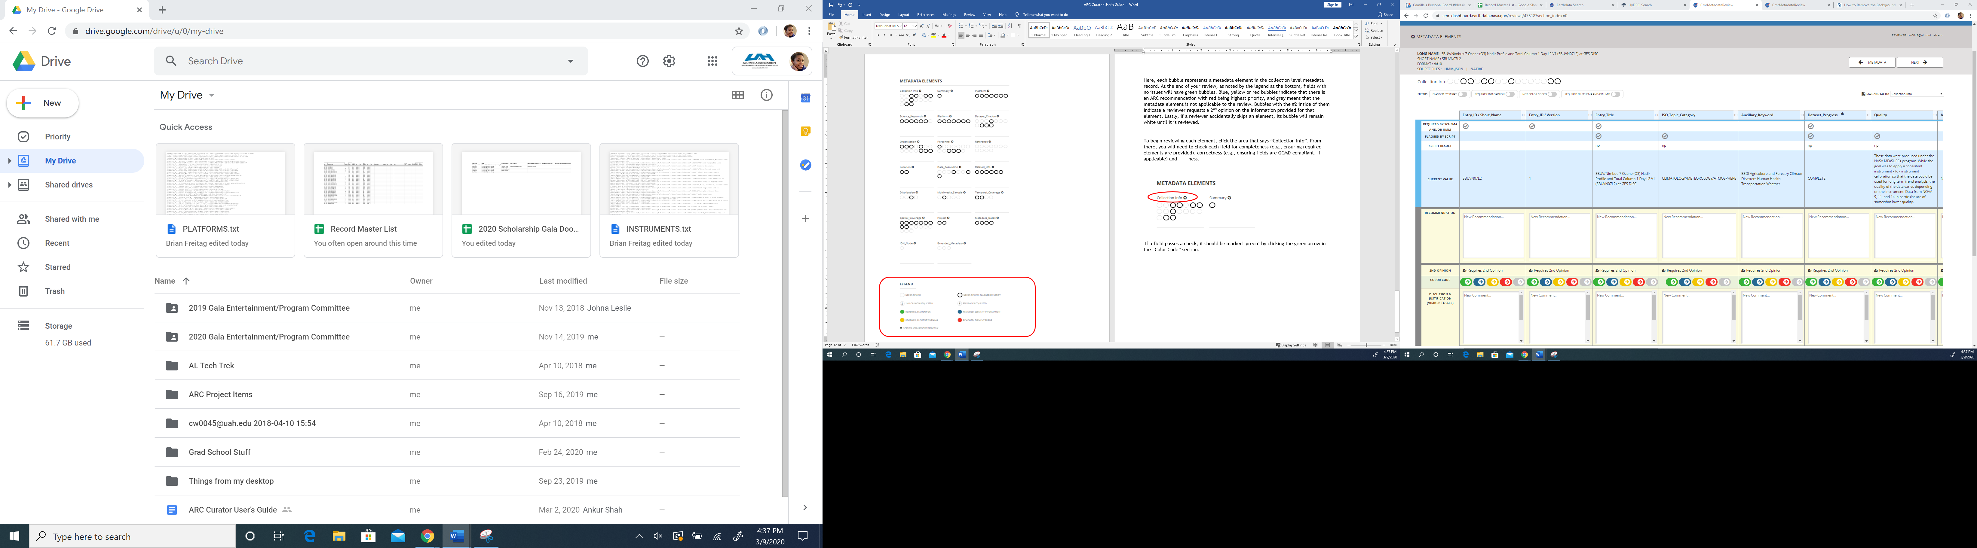 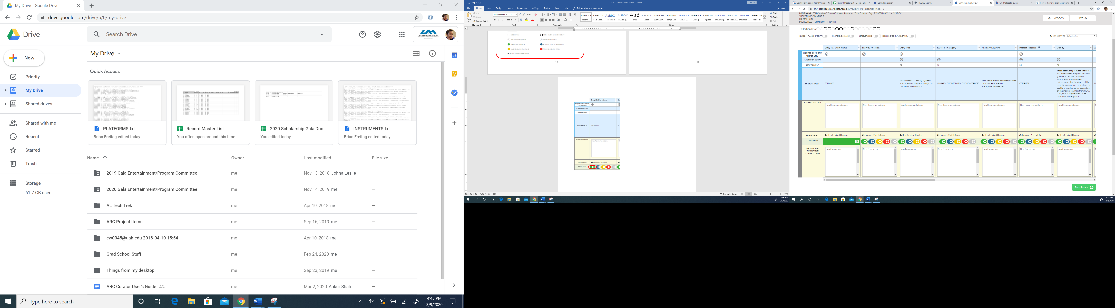

If a field does not pass a check, select the appropriate color flag and make recommendations in the box labeled “Recommendation”.

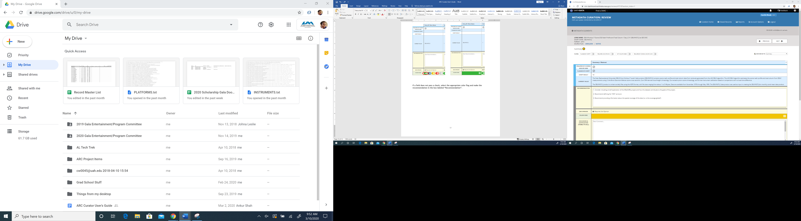

Once you are finished reviewing the elements in one section, hit the “Next” button in the top right corner to advance to the next set of elements.   
**Note**: Not only will this take you to the next screen, but it will also save your progress.

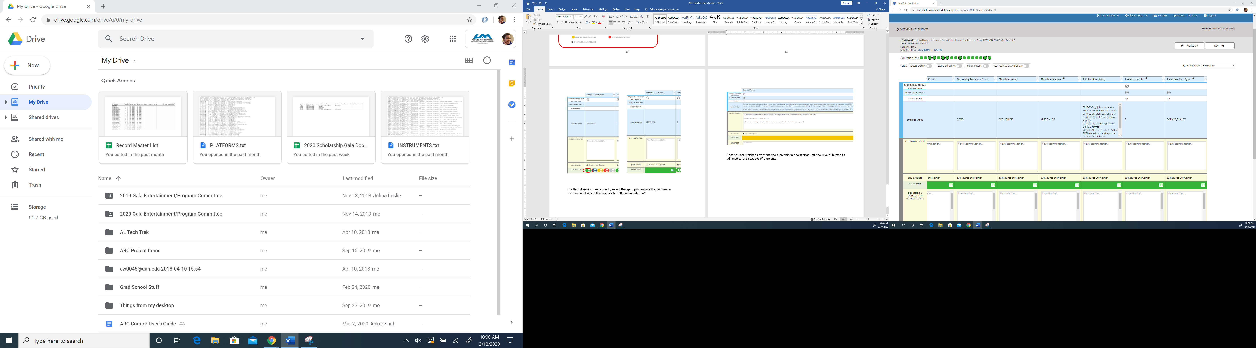

There are two other options to save your work in the dashboard. The first option is to hit “Save Review” in the bottom right hand corner of the page.

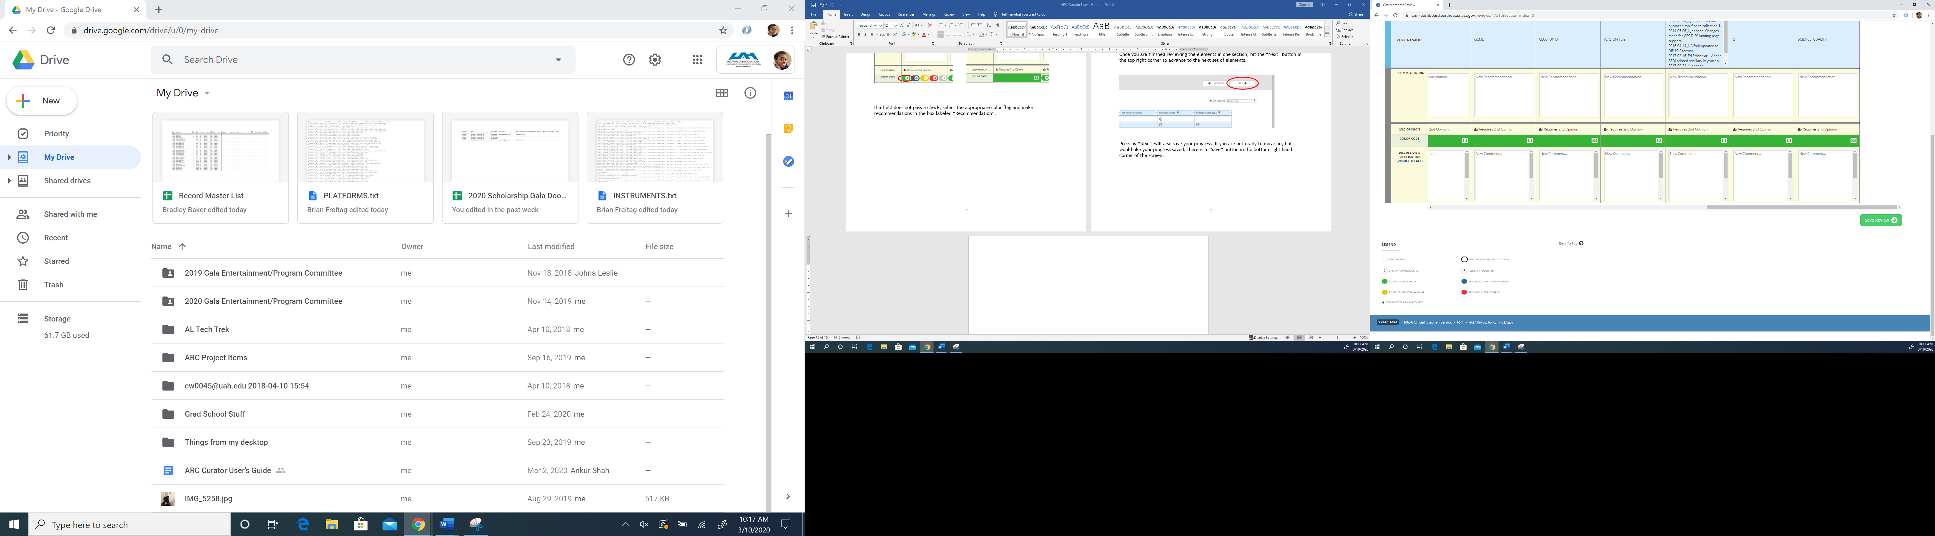

The second option is to use the “Save and Go To” drop down menu. This will also allow you to navigate between pages as you’re doing reviews.

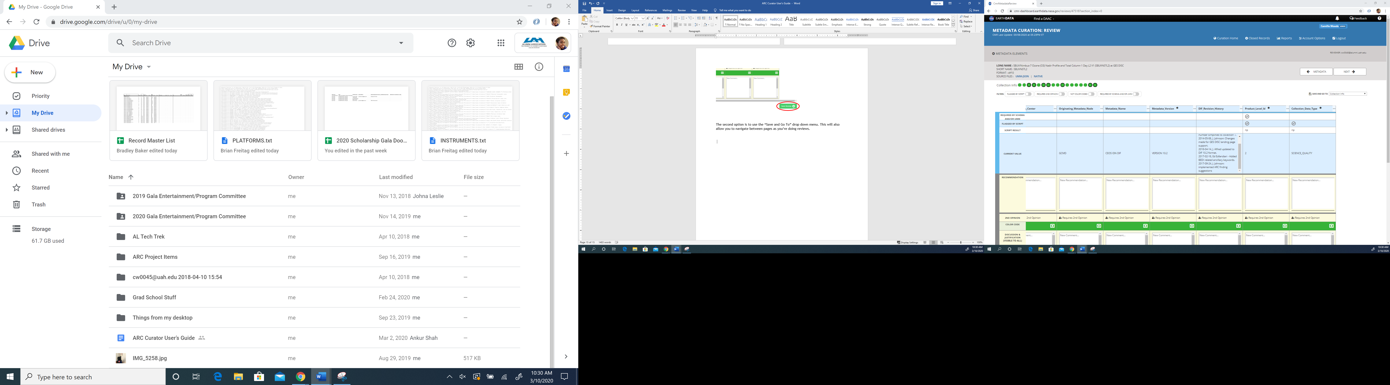

After you have completed your review of the collection level metadata elements, place your cursor in the box that says “Report Review Comments” and hit the space bar, making sure you do not type anything else in this section as comments made here cannot be altered or deleted at this time. This will activate the “Review Complete” button, which you will need to click to indicate that you have finished your review.

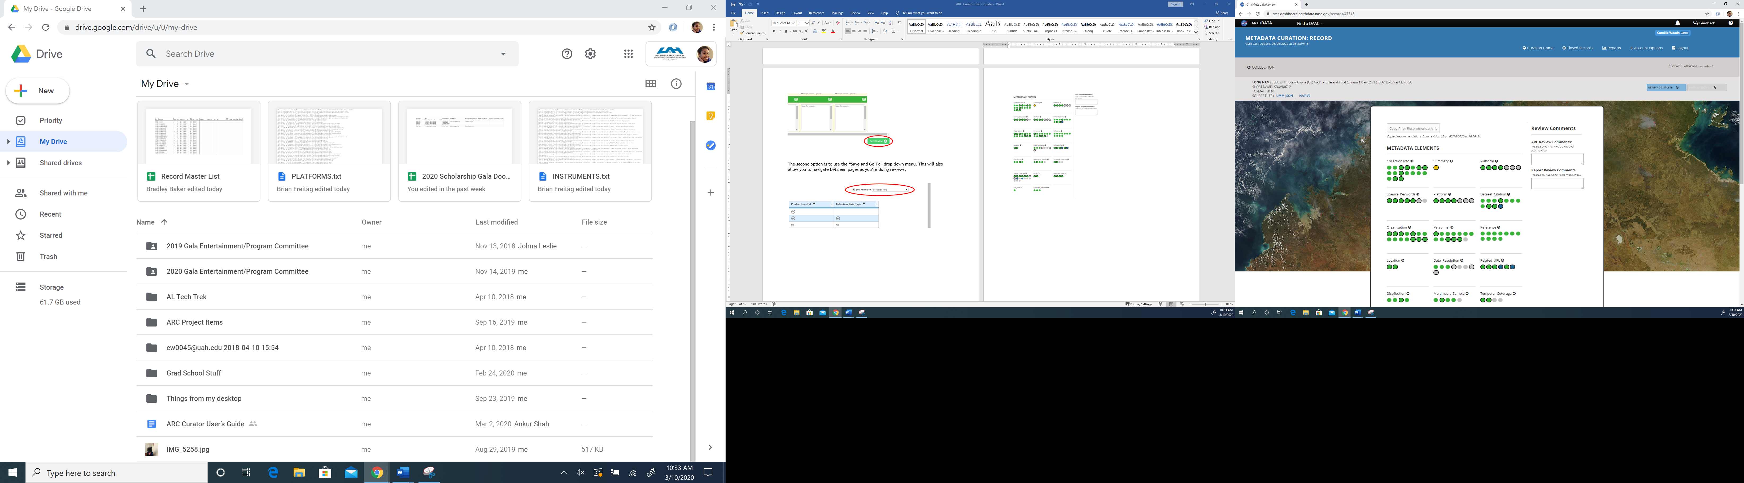

From there, click the “Collection” button in the top left corner of the page to take you back to the overview page for the collection and granule metadata elements.

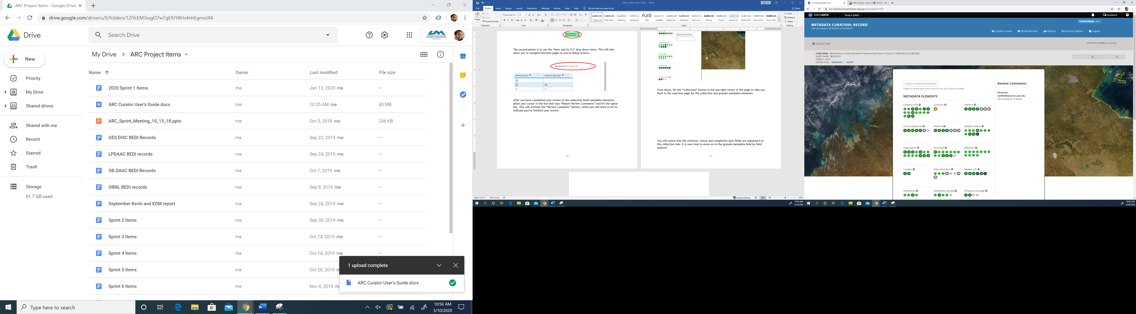

Once there, you should notice that the reviewer, status and completion date fields are populated on the collection side, indicating you have finished the first review for the collection. It is now time to begin reviewing the granule metadata elements.

Reviewing a Granule

Now that we’re back on the collection and granule homepage, there are a few additional buttons on the granule side that we need to point out.

Click here when there is a specific granule from a collection that you’d like to review

Click here to ingest a new granule (e.g., when a granule is no longer available for NRT collections)

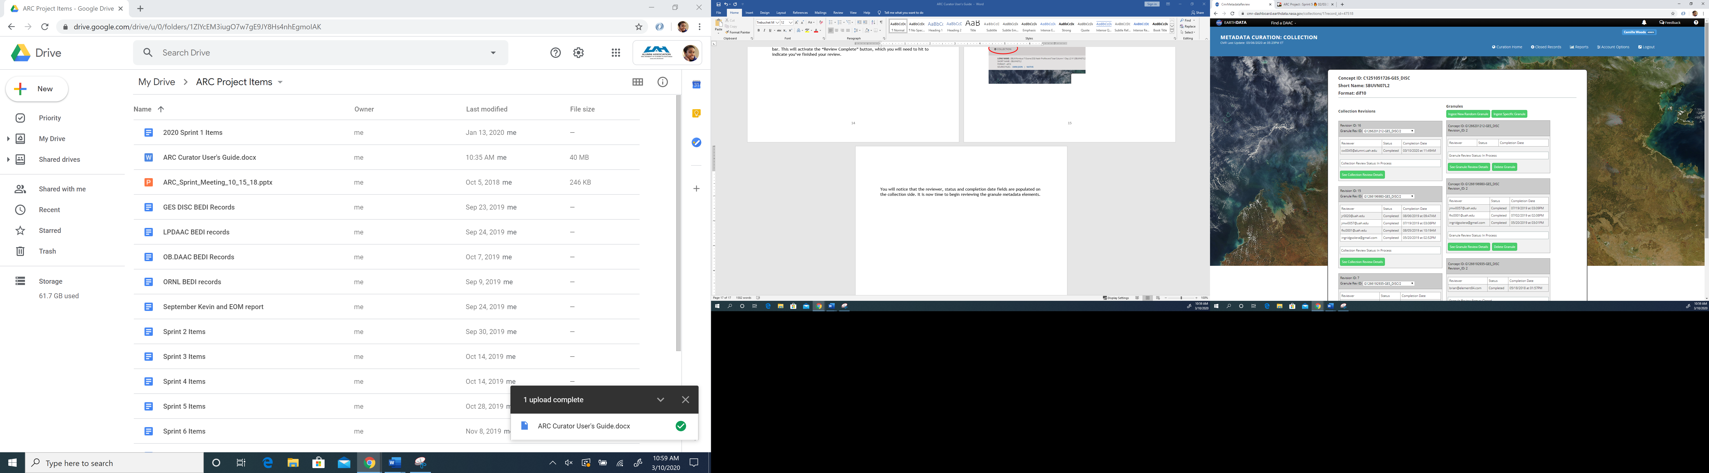

Click here when a granule needs to be deleted (e.g., when multiple granules are brought in for the same collection)

The steps for reviewing a granule are the same as reviewing the collection. Begin your review by clicking “See Granule Review Details”. This will take you to the granule metadata elements overview page, which should look similar to the collection level overview page with fewer elements:

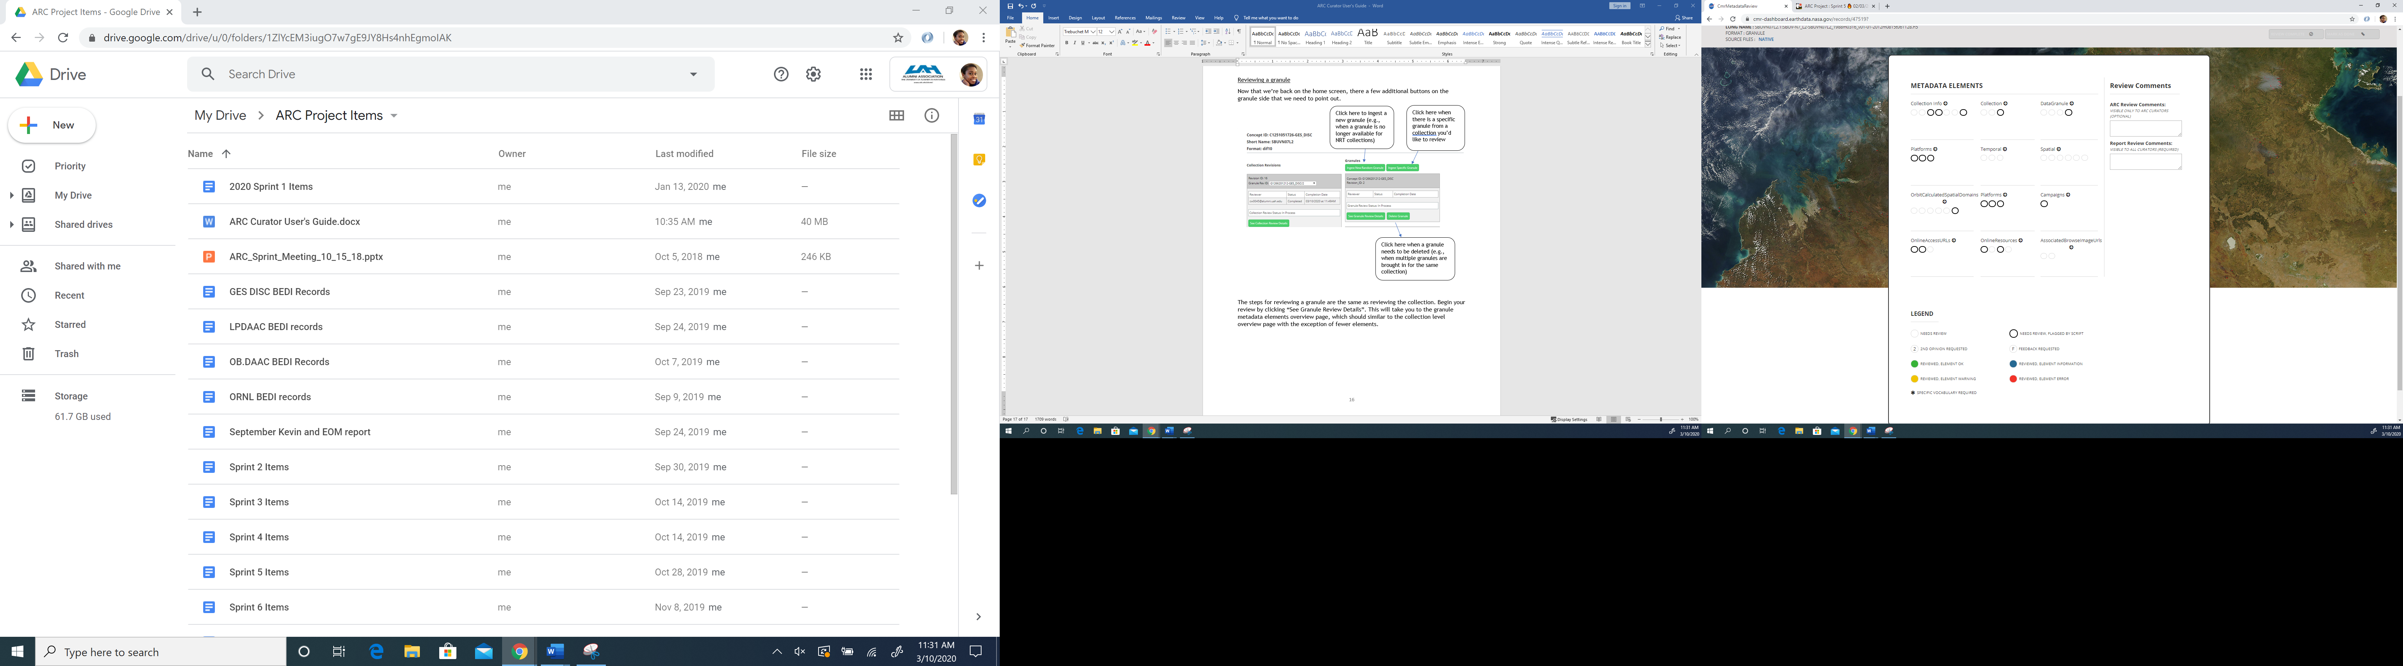

From there, select “Collection Info” and begin checking each field for completeness (e.g., ensuring required elements are provided), correctness, and consistency (e.g., ensuring fields are GCMD-compliant, if applicable). If a field passes a check, it should be marked ‘green’; otherwise select the appropriate color flag and make recommendations in the recommendation box.

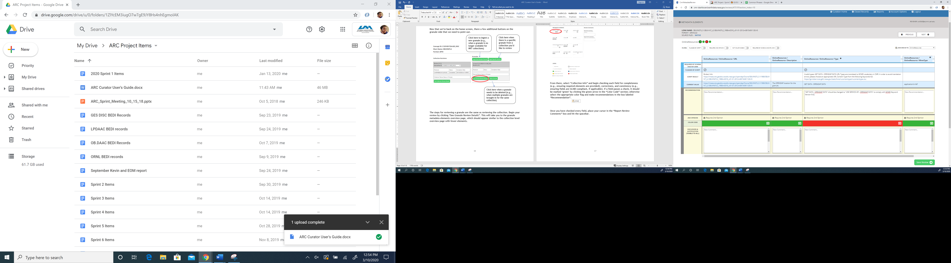

Once you have checked every field, place your cursor in the “Report Review Comments” box and hit the spacebar. This will activate the “Review Complete” button, which you will need to hit to indicate you’ve finished your review.

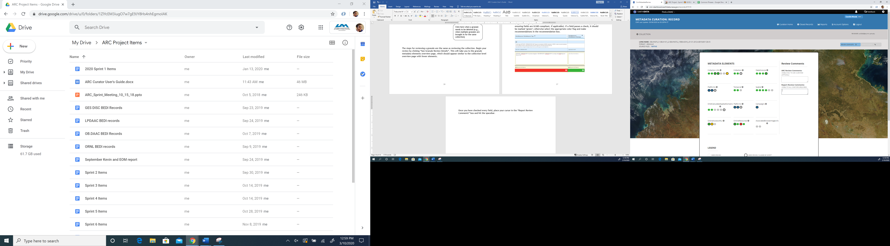

From there, hit “Collection” in the top left-hand corner of the screen to take you back to the overview page for the collection and granule metadata elements. Now both the collection and granule review status should say “Completed”. If either one says, “In Process”, go back in and ensure you’ve hit the “Review Complete” button.

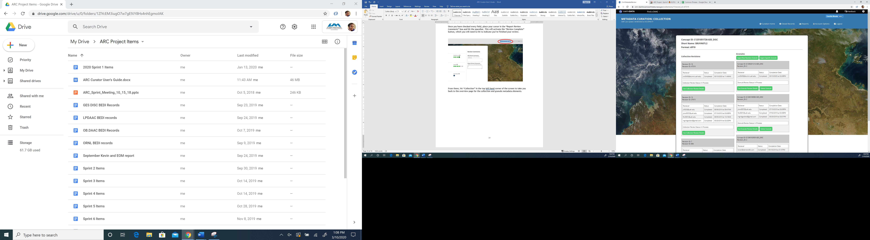

Now it is time for the second reviewer to begin their review. After logging into the dashboard, the second reviewer will need to use the Ctrl+f shortcut to find the record they will be reviewing. You will notice the record now appears in the “In ARC Review Records” section since it has already been reviewed once. From there, select the record (which should be highlighted) and click on “See Review Detail”.

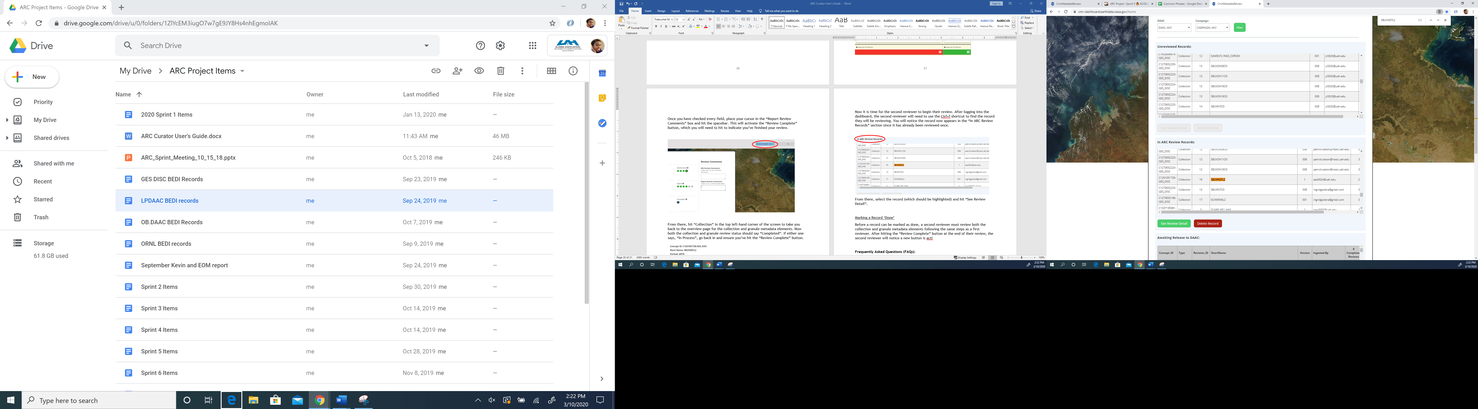

The second reviewer should then complete their review using the same steps as the first reviewer, starting with the collection level metadata elements. After checking each field and pressing “Review Complete”, the second reviewer will then need to do the same with the granule metadata elements. Once both reviews are complete, the second reviewer should let admins know that the record is ready to be checked and subsequently released to a DAAC. This can be achieved by utilizing the “Mark As Done” button.

Marking a Record ‘Done’

As the second reviewer completes their granule review and hits the “Complete Review” button, they will notice a new button, “Mark As Done”, is activated. Press this button and you should be automatically redirected to the collection and granule homepage.

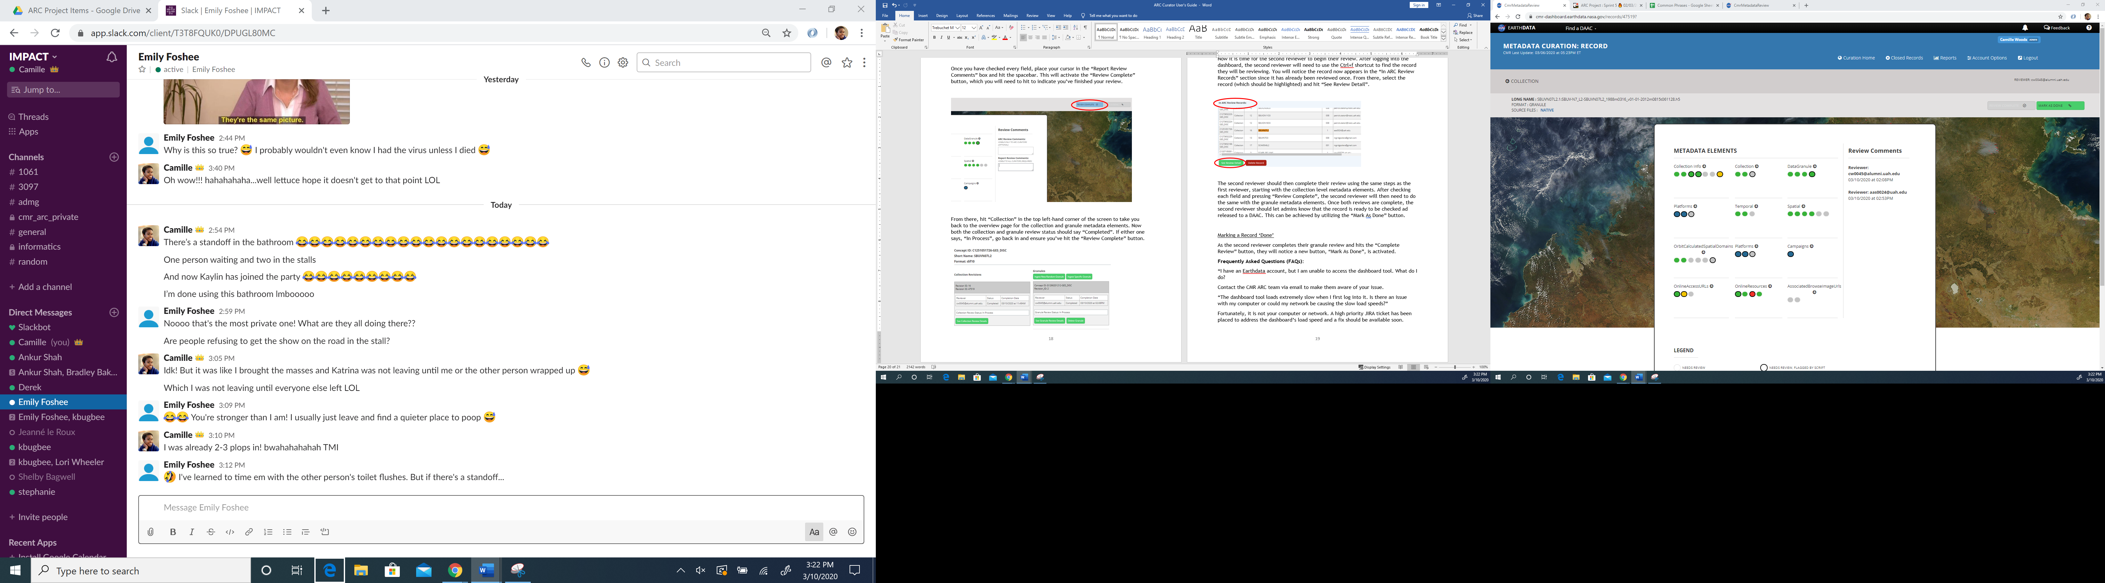

Once back on the homepage, click “See Collection Review Details”. You will notice “Mark As Done” is also activated on the collection page. Press it and you’ll be returned to the collection and granule metadata homepage. You should now see the second reviewer’s review status listed as “Completed” for both the collection and granule.

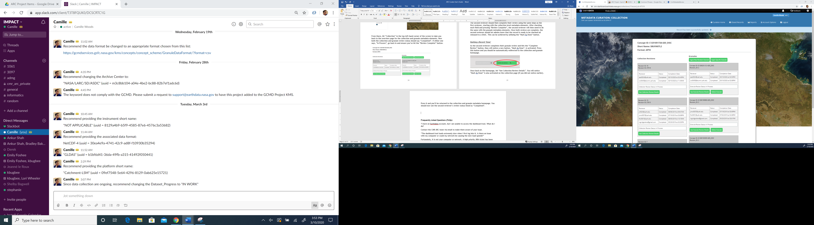

After both reviews are complete, an admin will double-check the record and release it to the appropriate DAAC, at which point overview and improvement metrics can be generated.

**Obtaining Metrics:**

In the top right-hand corner of the homepage, there is a navigation panel. Hover your mouse over the “Reports” tab.

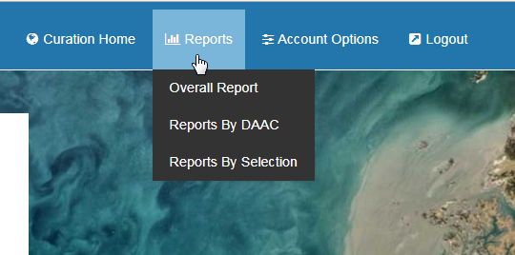

Click on “Overall Report” to see overview metrics for all records that have been imported into the dashboard. Overview metrics show ARC’s review progress, a before and after snapshot of metadata quality, and elements that have a high frequency of error split between collections & granules.

Click on “Reports By DAAC” to get the same overview metrics for a specific DAAC by selecting a DAAC from the drop down menu. **Note:** DAACs are currently identified via CMR provider ID.

Click on “Reports By Selection” to get the same overview metrics for a custom sub-set of records. Use the search bar to query for records to include in your subset. For example, these are the results for the search term “ACCP”:

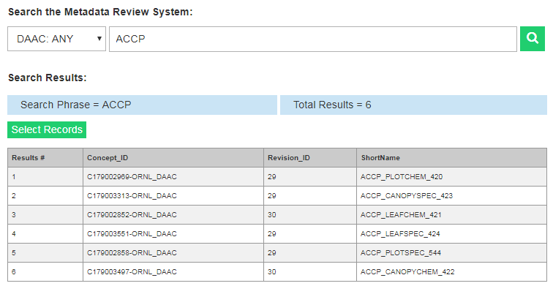

Click on the records you would like to see summarized in the report. The records you select will be highlighted in light blue. In the below example, the first four records have been selected.

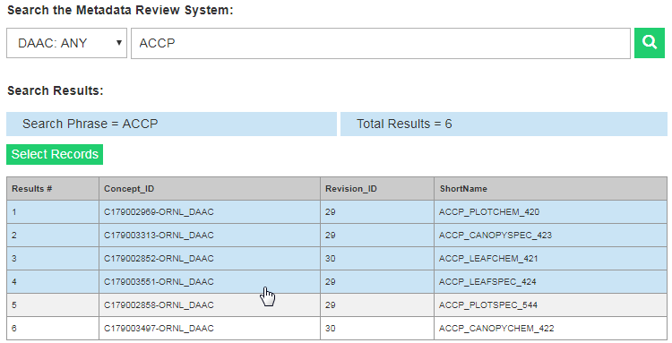

Once the desired records have been selected, click on the green “Select Records” button to generate the report.

This final section concludes the overview of the curation process using the dashboard. This procedure will enable you to significantly improve the discovery and usability of Earth science datasets owing to your recommendations for enhancing the quality of their associated metadata. Frequently asked questions about using the dashboard can be found in the next section. If you have further questions, a list of personnel who can further assist you is included at the end of this document.

**Frequently Asked Questions (FAQs):**

**Q:** “I have an Earthdata account, but I am unable to log-in the dashboard. What do I do?”

**A:** Contact the CMR ARC team via email so they can ensure you have access to the dashboard.

**Q:** “The dashboard loads extremely slow when I first log into it. Is there an issue with my computer or could my network be causing the slow load speeds?”

**A:** A high priority JIRA ticket has been submitted to address the dashboard’s load speed and a fix should be available soon.

**Q:** “Why do I get a “Python Script Timeout” error when I try to ingest new records?”  
**A:** The dashboard will time out from time to time. Try ingesting the records after waiting a few minutes. If the problem persists, contact the CMR ARC team via email.

**Q:** “When I search for a record, multiple records are returned in my search. Which one should I review?”  
**A:** A general rule of thumb is to review the record with the newest revision ID. If there are multiple records with the same version *and* revision ID, ask an admin to delete the duplicate records. In the example below, only one of the records with a revision ID of 32 should be reviewed and the rest can be deleted.

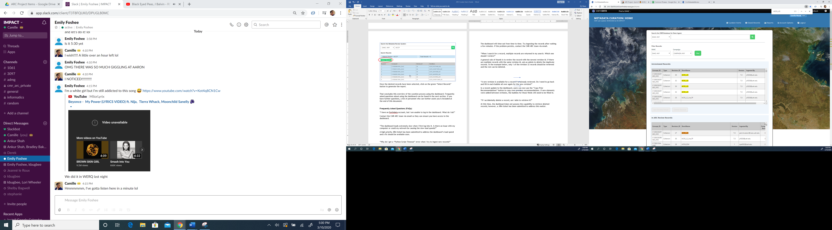

Review

Delete

Delete

Delete

**Q:** “A new revision is available for a record I’ve already reviewed. Do I need to go back and fill in each bubble all over again for the new revision?”  
**A:** In a recent update to the dashboard, users can now use the “Copy Prior Recommendations” button to copy over previous recommendations (circled below). If new elements were added between revisions, the bubbles for those fields will need to be filled in.

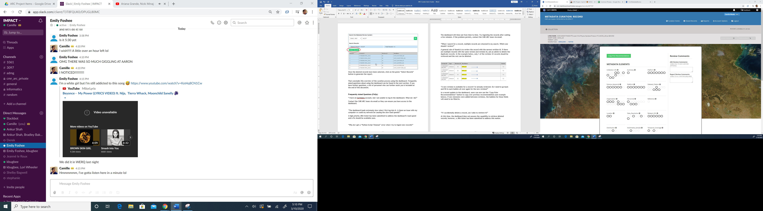

**Q:** “If I accidentally delete a record, am I able to retrieve it?”  
**A:** At this time, the dashboard does not possess the capability to retrieve deleted records; however, a JIRA ticket has been submitted to address this matter.

For additional questions and information regarding the dashboard, please feel free to contact the following individuals:

CMR ARC Team (for general inquiries): xxxx@gmail.com

Metadata Tools Team (for technical issues): xxxx@nasa.gov